**Emergency Information on Mobile**

Software Design Document

By

Putchakarn Jaikon 542115031

Sawatdiporn Kitirot 542115065

Department of Software Engineering

College of Arts, Media and Technology

Chiang Mai University

Project Advisor

__________________________________

**Aj.Chartchai Doungsa-ard**

**Document History**

|  |  |  |  |  |  |  |
| --- | --- | --- | --- | --- | --- | --- |
| **Document Name** | **Details** | **Status** | **Date** | **Viewable** | **Reviewer** | **Responsible** |
| **Documents** | | | | | | |
| **EIOM-SDD-V.0.1.docx** | **Chapter 1**  •    Introduction | Draft | 1/4/2014 | PJ, SK, CD | PJ, SK | PJ, SK |
| **EIOM-SDD-V.0.2.docx** | **Chapter 2**  •    System Architecture  **Chapter 3**  •    Detailed Design | Draft | 17/4/2014 | PJ, SK, CD | PJ, SK | PJ, SK |
| **EIOM-SDD-V.0.3.docx** | **Modify Chapter 3**  •    Class Diagram  •    Class Diagram Description  •    Sequence Diagram | Draft | 23/4/2014 | PJ, SK, CD | PJ, SK | PJ, SK |
| **EIOM-SDD-V.0.4.docx** | **Chapter 4**  •    User Interface Design | Draft | 28/4/2014 | PJ, SK, CD | PJ, SK | PJ, SK |
| **EIOM-SDD-V.0.5.docx** | **Modify Chapter 4**  •    User Interface Design | Draft | 30/4/2014 | PJ, SK, CD | PJ, SK | PJ, SK |
| **EIOM-SDD-V.0.6.docx** | **Modify Chapter 3**  •    Class Diagram Description | Draft | 1/5/2014 | PJ, SK, CD | PJ, SK | PJ, SK |
| **EIOM-SDD-V.0.7.docx** | •    Add Table of content and cover page | Draft | 4/5/2014 | PJ, SK, CD | PJ, SK | PJ, SK |
| **EIOM-SDD-V.1.0.docx** | **Modify Chapter 3**  •    Class Diagram  •    Class Diagram Description  •    Sequence Diagram  **Modify Chapter 4**  •    User Interface Design | Release | 10/5/2014 | PJ, SK, CD | PJ, SK | PJ, SK |
| **EIOM-SDD-V.1.1.docx** | •    Modify Chapter 1-4 | Release | 30/7/2014 | PJ, SK, CD | PJ, SK | PJ, SK |
| **EIOM-SDD-V.2.0.docx** |      •  Modify feature5,CDs-04,05,16       •  Add MDs-61 – MDs-73 •  Add MDm-24 – MDm-51 | Release | 21/10/2014 | PJ, SK, CD | PJ, SK | PJ, SK |
| **EIOM-SDD-V.2.1.docx** |      •  Modify system architecture (Add feature 6) | Release | 11/11/2014 | PJ, SK, CD | PJ, SK | PJ, SK |

PJ – Putchakarn Jaikon, SK – Sawatdiporn Kitirot, CD – Chartchai Doungsa-ard

Table of Contents

Chapter One | Introduction 4

1.1 Objective 4

1.2 Project Scope 4

1.3 Purpose 4

1.4 Acronyms and Definitions 4

Chapter Two | System architecture 6

Chapter Three | Detailed Design 9

3.1 Class Diagram 9

3.2 Class Diagram Description 14

3.3 Sequence Diagram 66

Chapter Four | User Interface Design 73

# Chapter One | Introduction

## 1.1 Objective

The purpose of the software design document (SDD) for Emergency Information on Mobile project is to design the detailed structure of the system accordance with the software requirement specification (SRS). This SDD also making the members in the project team understand the work in the detailed design of the system using the class diagram, sequence diagram, entity relationship diagram and user interface design.

## 1.2 Project Scope

Emergency Information on Mobile is composed of two parts that are server and mobile part. The server part uses to manage the information of help place. The mobile application part runs on Android OS. Emergency Information on Mobile will provide the necessary information of help places to the user.

## 1.3 Purpose

This software design document consists of progress report I. So the stakeholder of Emergency Information on Mobile can review software design in this progress.

## 1.4 Acronyms and Definitions

1.4.1 Acronyms

EIOM Emergency Information on Mobile

SDD Software Design Document

UI User Interface

CDs Class Diagram Server

CDm Class Diagram Mobile

MDs Method Description Server

MDm Method Description Mobile

1.4.2 Definitions

|  |  |
| --- | --- |
| Sequence diagram | A sequence diagram in a [Unified Modeling Language](http://en.wikipedia.org/wiki/Unified_Modeling_Language) (UML) is a kind of [interaction diagram](http://en.wikipedia.org/wiki/Interaction_diagram) that shows how processes operate with one another and in what order. It is a construct of a Message Sequence Chart. A sequence diagram shows object interactions arranged in time sequence. It depicts the objects and classes involved in the scenario and the sequence of messages exchanged between the objects needed to carry out the functionality of the scenario. |
| Feature | Transformation of input parameters to output parameters based on a specified algorithm. It describes the functionality of a product in the language of the product. Used for requirements analysis, design, coding, testing or maintenance.[IEEE90] |
| IEEE | Institute for Electrical and Electronics Engineers. Biggest global interest group for engineers of different branches and for computer scientists. [IEEE90] |
| User Interface | The portion of a computer program with which the user interacts, i.e., the interface between a user and a computer program. There are command-line interfaces, menu-driven interfaces, and graphical user interfaces (GUIs). |
| UML | Unified Modeling Languages. Standardized notation for Modeling design descriptions, architectures or scenarios. Not depending on a specific method. Issued and maintained byte object Management Group (OMG).[IEEE90] |

# Chapter Two | System architecture

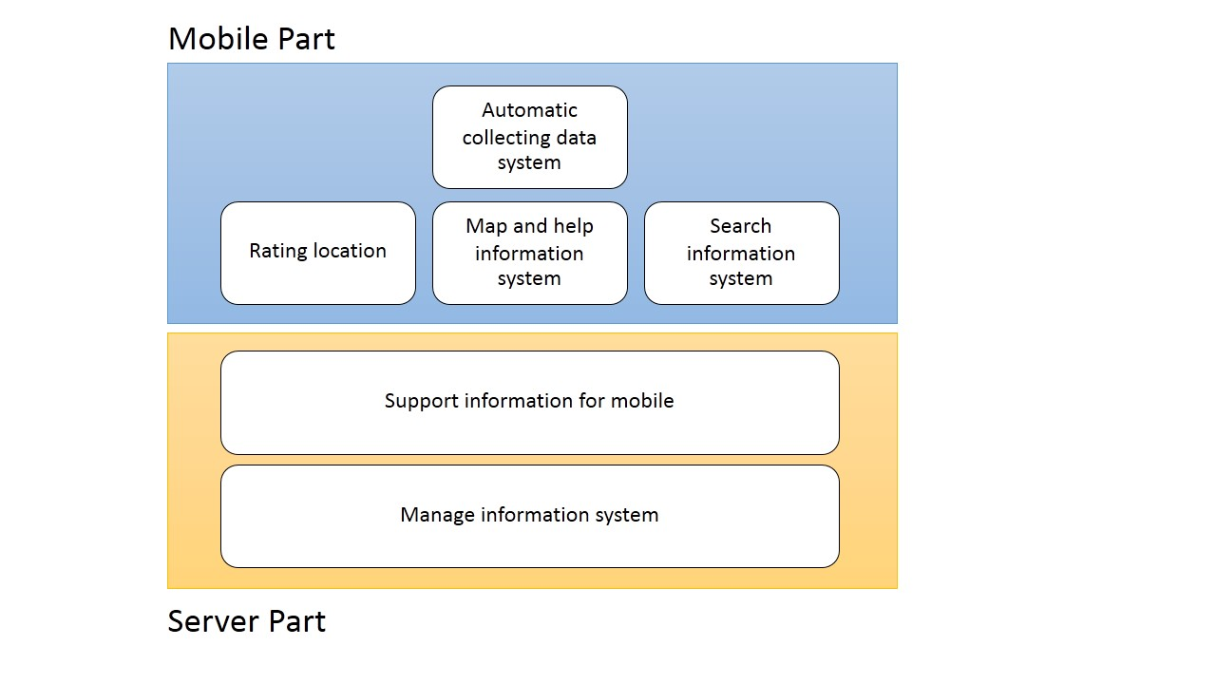

**Figure 1 Architecture overview of Emergency Information on Mobile system**

Figure 1 shows overall of architecture such as map and help information system, search information system and manage information system.

|  |  |  |  |
| --- | --- | --- | --- |
| **Feature** | **Function name** | **Online** | **Offline** |
| **Feature 1:** Map and help information system | View map and help places | √ | √ |
| View information of help places | √ | √ |
| Make emergency call | √ | √ |
| **Feature 2:** Search information system | Search the help place by keyword | √ |  |
| Find the nearest help place | √ | √ |
| **Feature 3:** Rating location | Rate the help place | √ |  |
| View average rating score | √ | √ |
| **Feature 4:** Automatic collecting data system | Download data of help place automatically | √ |  |
| Set the scope for downloading data | √ |  |
| **Feature 5:** Manage information system | Add help place | √ |  |
| Edit help place | √ |  |
| Remove help place | √ |  |
| View information of the help place | √ |  |
| Browse the help place by category | √ |  |
| Browse the help place by province | √ |  |
| Browse the help place by help place’s category and help place’s province | √ |  |
| **Feature 6:** Support information for mobile | Sent nearest help place in JSON form | √ |  |
| Sent list of all help places in JSON form | √ |  |
| Sent list of all help places in setting scope in JSON form | √ |  |

**Mobile Part**

**Feature 1: Map and help information system**

In this feature, the help place will show on the map with their information such as address and phone number. Moreover, the phone number can be called directly on the application.

**Feature 2: Search information system**

Feature 2 provides search help place by keyword or name of help place. Furthermore, the application can show the nearest help place in many categories such as a police station, hospital, and garage.

**Feature 3: Rating location**

In this feature, the user can use the rate function to rate each help place. One user will be count at one for rating each place. The rating location collects the rate and provides the average rate to the user. Furthermore, the rate function will help the user to compose their decision to go among many help places.

**Feature 4: Automatic collecting data system**

Feature 4 will download data of help place around the user automatically and save into a mobile device. So, the information can show without the internet connection. In addition, the user can set the scope of download data.

**Server part**

**Feature 5: Manage information system**

Feature 5 furnishes manage information system to admin. The administrator can add, edit, remove, view information of the help place. Moreover, the administrator can browse the help place by selecting category or province. In addition, the server supports information of help place in JSON form to the mobile application.

**Feature 6: Support information for mobile**

Feature 6 will build information in form of JSON to support the mobile application.

# Chapter Three | Detailed Design

## 3.1 Class Diagram

3.1.1 Server Part

Controller class diagram

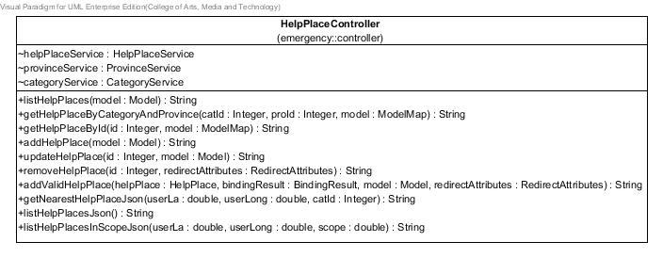

**Figure 1 Controller class diagram**

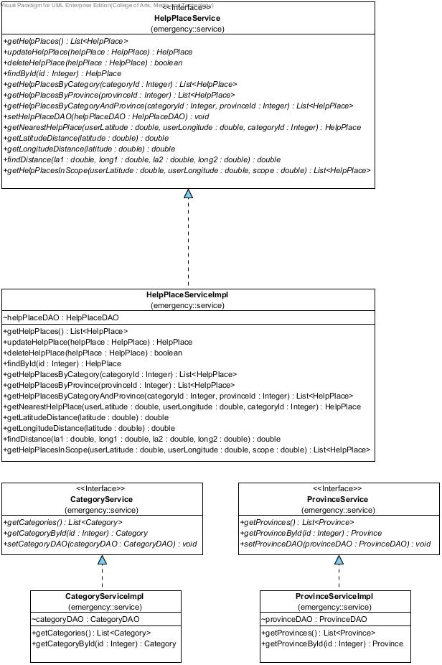Service class diagram

**Figure 2 Service class diagram**

DAO class diagram

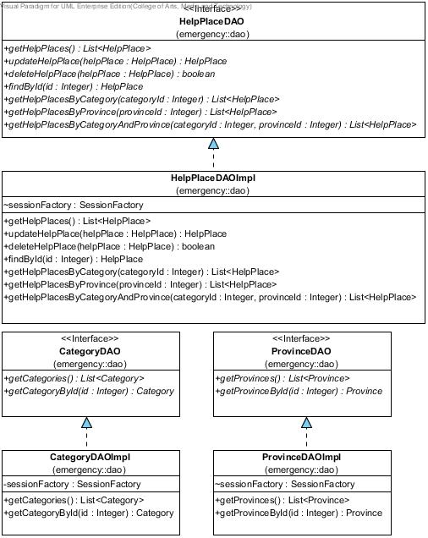

**Figure 3 DAO class diagram**

Entity class diagram

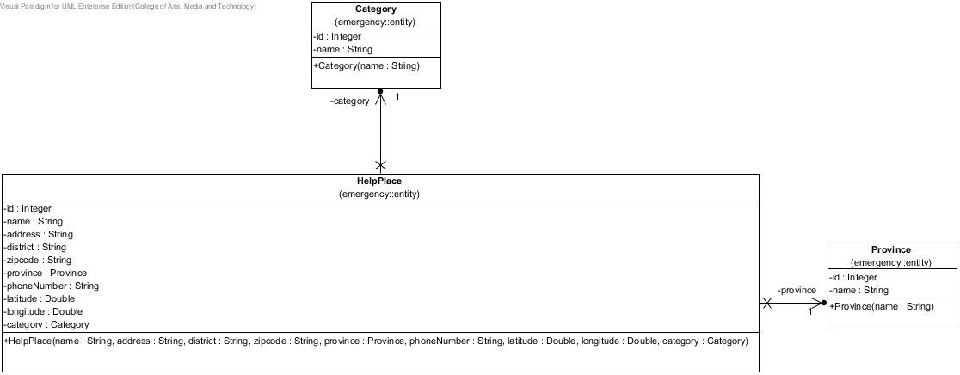

**Figure 4 Entity class diagram**

3.1.2 Mobile Part

Emergency Information on Mobile class diagram

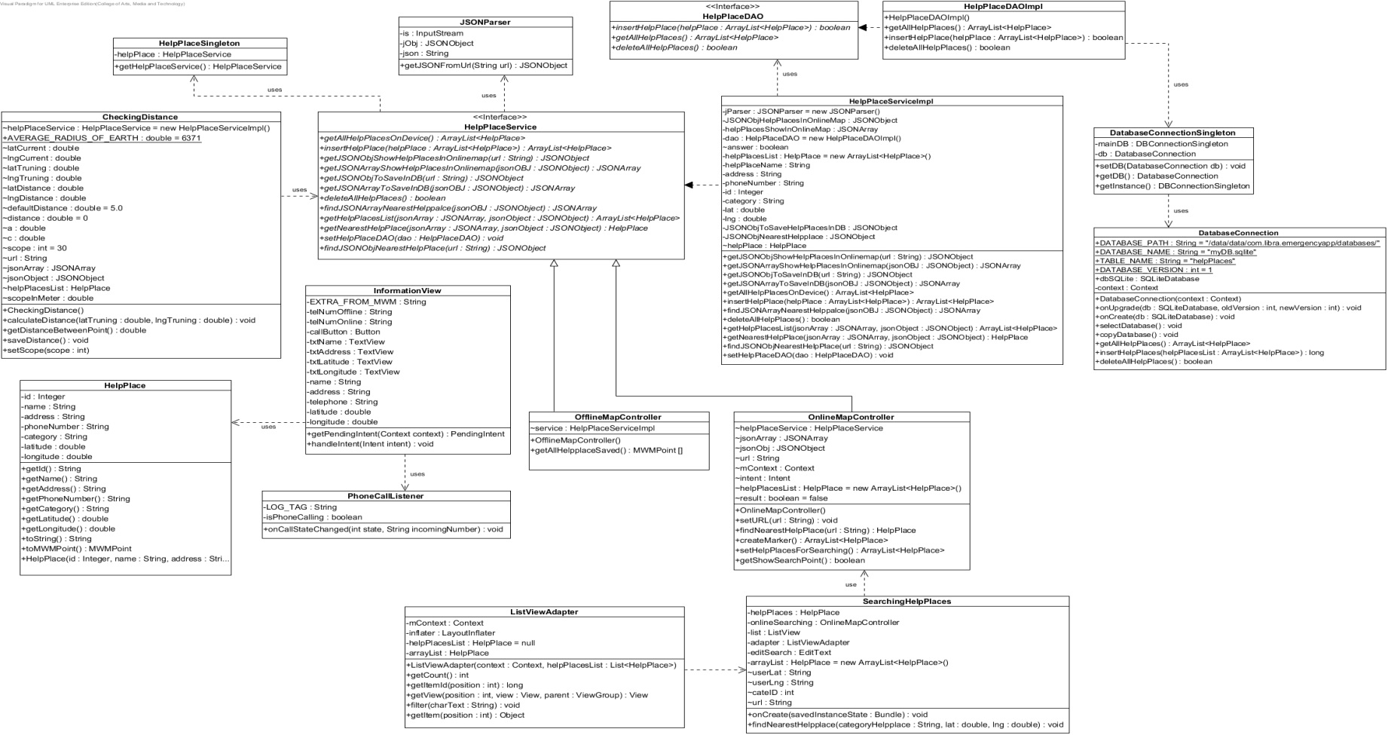

**Figure 5 Emergency Information on Mobile class diagram**

## 3.2 Class Diagram Description

3.2.1 Server Part

1. HelpPlace

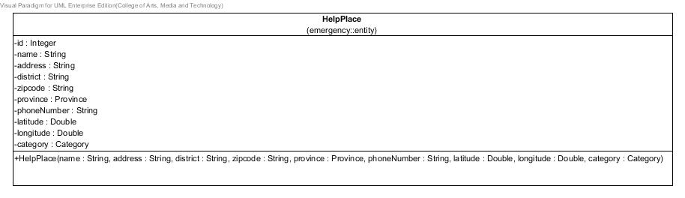

**Figure 6 HelpPlace class**

**Entities**

|  |  |  |  |
| --- | --- | --- | --- |
| **ID** | **Name** | **Description** | **Type** |
| 1 | id | stored id of the help place | Integer |
| 2 | name | stored name of the help place | string |
| 3 | district | stored district of the help place | string |
| 4 | province | stored province object of the help place | Province |
| 5 | zipCode | stored zipcode of the help place | string |
| 6 | phoneNumber | stored phone number of the help place | string |
| 7 | latitude | stored latitude of the help place | Double |
| 8 | longitude | stored longitude of the help place | Double |
| 9 | category | stored category object of the help place | Category |

**Method details**

1. HelpPlaces

public HelpPlace(String name, String address, String district, String zipcode, Province province, String phoneNumber, Double latitude, Double longitude, Category category)

**Description:** A constructor method is used to set the attributes of help place object.

1. HelpPlaceDAO

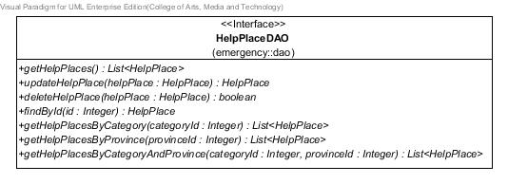

**Figure 7 HelpPlaceDAO class**

**Method details**

1. getHelpPlaces

public List<HelpPlace> getHelpPlaces()

**Description:** Get a list of help places from the database.

**Return:** Lists of the help places in the database.

1. updateHelpPlace

public HelpPlace updateHelpPlace(HelpPlace helpPlace)

**Description:** Update information of the help place to the database.

**Parameter:** helpPlace-HelpPlace uses for update information of the help place to the database.

**Return:** Help place object that needs to update.

1. deleteHelpPlace

public boolean deleteHelpPlace(HelpPlace helpPlace)

**Description:** Delete the help place from database.

**Parameter:** helpPlace-HelpPlace uses for delete the help place from database.

**Return:** Boolean, if the help place has been deleted, will return true.

1. findById

public HelpPlace findById (Integer id)

**Description:** Get help place by id from the database.

**Parameter:** id-Integer uses for getting the help place.

**Return:** The help place from database.

1. getHelpPlacesByCategory

public List<HelpPlace> getHelpPlacesByCategory(Integer categoryId)

**Description:** Get help places from the database by the selected category id.

**Parameter:** categoryId-Integer uses for getting the help place from database.

**Return:** Lists of the help places that contain the selected category, from database.

1. getHelpPlacesByProvince

public List<HelpPlace> getHelpPlacesByProvince(Integer provinceId)

**Description:** Get help places from the database by the selected province id.

**Parameter:** provinceId -Integer uses for getting the help place from database.

**Return:** Lists of the help places that contain the selected province, from database.

1. getHelpPlacesByCategoryAndProvince

public List<HelpPlace> getHelpPlacesByCategoryAndProvince (Integer categoryId, Integer provinceId)

**Description:** Get help places from the database by the selected category id and province id.

**Parameter:** provinceId–Integer and categoryId-Integer use for getting the help place from database.

**Return:** Lists of the help places that contain the selected category and province, from database.

1. HelpPlaceDAOImpl

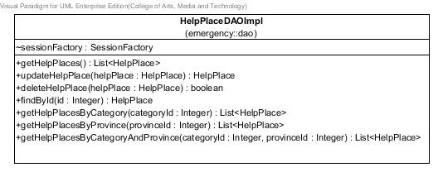

**Figure 8** HelpPlaceDAOImpl **class**

**Entities**

|  |  |  |  |
| --- | --- | --- | --- |
| **ID** | **Name** | **Description** | **Type** |
| 1 | sessionFactory | A thread-safe, immutable cache of compiled mappings for a single database | SessionFactory |

**Method details**

1. getHelpPlaces

public List<HelpPlace> getHelpPlaces()

**Description:** Get help places from the database by using session to query data.

**Flow:**

1. Create list of help place to store data.
2. Create query to get all help places.
3. Store the queried data in list.
4. Return the list.

**Return:** List of help places in database.

1. updateHelpPlace

public HelpPlace updateHelpPlace(HelpPlace helpPlace)

**Description:** Update information of the help place to database by using session to query data.

**Parameter:** helpPlace-HelpPlace uses for update information of the help place to database.

**Flow:**

1. Create query to update the help place where help place equal to helpPlace.
2. Return helpPlace.

**Return:** Help place object that needs to update.

1. deleteHelpPlace

public boolean deleteHelpPlace(HelpPlace helpPlace)

**Description:** Delete the help place from database by using session to query data.

**Parameter:** helpPlace-HelpPlace uses for delete the help place from database.

**Flow:**

1. Create Boolean equal to false.
2. If helpPlace-HelpPlace not equal to null.
3. Create id-Integer to store ID of helpPlace-HelpPlace, which comes from parameter.
4. Create helpPlace-HelpPlace to store data.
5. Create query to get the help place where help place’s id equal to id-Integer.
6. Store the queried data in helpPlace-HelpPlace object.
7. Create query to delete help place where help place in database equal to helpPlace-HelpPlace.
8. Update Boolean equal to true.
9. Return Boolean.

**Return:** Boolean, if the help place has been deleted, will return true.

1. findById

public HelpPlace findById (Integer id)

**Description:** Get help place from the database by using session to query data.

**Parameter:** id-Integer uses for getting the help place.

**Flow:**

1. Create query to get help place where help place’s id in database equal to id-Integer, which is received in parameter.
2. Return the queried data.

**Return:** The help place that contains the inputted id, from database.

1. getHelpPlacesByCategory

public List<HelpPlace> getHelpPlacesByCategory(Integer categoryId)

**Description:** Get help places from the database by the selected category id and using session to query data.

**Parameter:** categoryId -Integer uses for getting the help place from database.

**Flow:**

1. Create list of help place to store data.
2. Create query to get help place where category’s id equal to categoryId.
3. Store the queried data in list.
4. Return lists of help places.

**Return:** List of the help places that contain the selected category, in database.

1. getHelpPlacesByProvince

public List<HelpPlace> getHelpPlacesByProvince(Integer provinceId)

**Description:** Get help places from the database by the selected province id and using session to query data.

**Parameter:** provinceId -Integer uses for getting the help place from database.

**Flow:**

1. Create list of help place to store data.
2. Create query to get help place where province’s id equal to provinceId.
3. Store the queried data in list.
4. Return the list of help places.

**Return:** List of help places that contain the selected province, in database.

1. getHelpPlacesByCategoryAndProvince

public List<HelpPlace> getHelpPlacesByCategoryAndProvince (Integer categoryId, Integer provinceId)

**Description:** Get help places from the database by selected category id and province id and using session to query data.

**Parameter:** provinceId –Integer and categoryId-Integer use for getting the help place from database.

**Flow:**

1. Create list of help place to store data.
2. Create query to get help place where province’s id equal to provinceId and category’s id equal to categoryId.
3. Store the queried data in list.
4. Return list of help places.

**Return:** List of help places that contain the selected category and province, from database.

1. HelpPlaceService

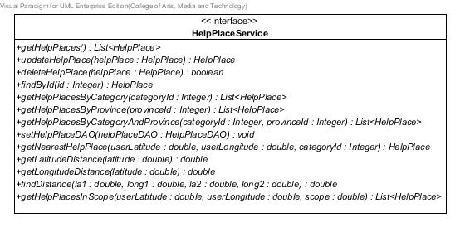

**Figure 9** HelpPlaceService **class**

**Method details**

1. getHelpPlaces

public List<HelpPlace> getHelpPlaces ()

**Description:** Get list of all help places from the database.

**Return:** List of all help places in database.

1. findById

public HelpPlace findById (Integer id)

**Description:** Get help place by id from the database.

**Parameter:** id-Integer uses for getting the help place.

**Return:** The help place in database.

1. updateHelpPlace

public HelpPlace updateHelpPlace(HelpPlace helpPlace)

**Description:** Update information of the help place to database.

**Parameter:** helpPlace-HelpPlace uses for update information of the help place to database.

**Return:** Help place object that needs to update.

1. deleteHelpPlace

public boolean deleteHelpPlace(HelpPlace helpPlace)

**Description:** Delete the help place in the database.

**Parameter:** helpPlace-HelpPlace uses for delete the help place from database.

**Return:** Boolean, if the help place has been deleted, will return true.

1. getHelpPlacesByCategory

public List<HelpPlace> getHelpPlacesByCategory(Integer categoryId)

**Description:** Get help places from the database by the selected category id.

**Parameter:** categoryId-Integer uses for getting the help place from database.

**Return:** List of help places that contain the selected category, in the database.

1. getHelpPlacesByProvince

public List<HelpPlace> getHelpPlacesByProvince(Integer provinceId)

**Description:** Get help places from the database by the selected province id.

**Parameter:** provinceId-Integer uses for getting the help place from database.

**Return:** List of help places that contain the selected province, in the database.

1. getHelpPlacesByCategoryAndProvince

public List<HelpPlace> getHelpPlacesByCategoryAndProvince (Integer categoryId, Integer provinceId)

**Description:** Get help places from the database by the selected category id and province id.

**Parameter:** provinceId–Integer and categoryId-Integer use for getting the help place from database.

**Return:** List of help places that contain the selected category and province, in database.

1. setHelpPlaceDAO

public void setHelpPlaceDAO(HelpPlaceDAO helpPlaceDAO)

**Description:** Set HelpPlaceDAO value into help place’s attribute.

**Parameter:** helpPlaceDAO–HelpPlaceDAO use for setting help place DAO.

**MDs-61:** getNearestHelpPlace

public HelpPlace getNearestHelpPlace(double userLatitude, double userLongitude, Integer categoryId)

**Description:** Get nearest help place from the database by the selected category id.

**Parameter:** userLatitude-double use for finding nearest help place.

userLongitude-double use for finding nearest help place.

categoryId-Integer use for getting the help place from database.

**Return:** Nearest help place by the selected category.

**MDs-62:** getLatitudeDistance

public double getLatitudeDistance(double latitude)

**Description:** Get surface distance per 1 degree change in latitude (meter).

**Parameter:** latitude-double use for finding surface distance per 1 degree change in latitude.

**Return:** Surface distance per 1 degree change in latitude in unit meter.

**MDs-63:** getLongitudeDistance

public double getLongitudeDistance(double latitude)

**Description:** Get surface distance per 1 degree change in longitude (meter).

**Parameter:** latitude-double use for finding surface distance per 1 degree change in longitude.

**Return:** Surface distance per 1 degree change in longitude in unit meter.

**MDs-64:** findDistance

public double findDistance(double la1, double long1,double la2, double long2)

**Description:** Get distance between two difference locations measures in unit meter.

**Parameter:** la1-double use for indicate latitude of location one.

long1-double use for indicate longitude of location one.

la2-double use for indicate latitude of location two.

long2-double use for indicate longitude of location two.

**Return:** Distance between two locations in unit meter.

**MDs-65:** getHelpPlacesInScope

public List<HelpPlace> getHelpPlacesInScope(double userLatitude, double userLongitude, double scope)

**Description:** Get list of help places in the setting area scope.

**Parameter:** userLatitude-double use for indicate user current location.

userLongitude-double use for indicate user current location.

scope-double use to define the scope for getting help places.

**Return:** List of help places locate in the selected scope.

1. HelpPlaceServiceImpl

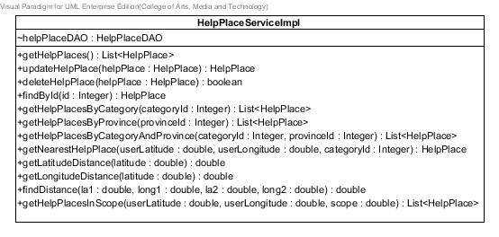

**Figure 10** HelpPlaceServiceImpl **class**

**Entities**

|  |  |  |  |
| --- | --- | --- | --- |
| **ID** | **Name** | **Description** | **Type** |
| 1 | helpPlaceDAO | Contained HelpPlaceDAO object | HelpPlaceDAO |

**Method details**

1. getHelpPlaces

public List<HelpPlace> getHelpPlaces()

**Description:** Get help places from the database through getHelpPlaces method of HelpPlaceDAO class.

**Flow:**

1. Use method getHelpPlaces()of HelpPlaceDAO class to get all help places.
2. Return list of all help places.

**Return:** List all help places in the database.

1. updateHelpPlace

public HelpPlace updateHelpPlace(HelpPlace helpPlace)

**Description:** Update information of the help place to the database through updateHelpPlace method of HelpPlaceDAO class.

**Parameter:** helpPlace-HelpPlace uses for update information of the help place to the database.

**Flow:**

1. Use method updateHelpPlace(helpPlace)of HelpPlaceDAO class to update help place.

**Return:** Help place object that needs to update.

1. deleteHelpPlace

public boolean deleteHelpPlace(HelpPlace helpPlace)

**Description:** Delete the help place from database through deleteHelpPlace method of HelpPlaceDAO class.

**Parameter:** helpPlace-HelpPlace uses for delete the help place from database.

**Flow:**

1. Use method deleteHelpPlace(helpPlace)of HelpPlaceDAO class to delete help place.

**Return:** Boolean, if the help place has been deleted, will return true.

1. findById

public HelpPlace findById(Integer id)

**Description:** Get help place from the database through findById method of HelpPlaceDAO class.

**Parameter:** id-Integer uses for getting the help place.

**Flow:**

1. Use method findById(id)of HelpPlaceDAO class to find the help place by using its id.

**Return:** The help place in the database.

1. getHelpPlacesByCategory

public List<HelpPlace> getHelpPlacesByCategory(Integer categoryId)

**Description:** Get help places from the database by selected category id through getHelpPlacesByCategory method of HelpPlaceDAO class.

**Parameter:** categoryId-Integer uses for getting the help place from database.

**Flow:**

1. Use method getHelpPlacesByCategory(categoryId)of HelpPlaceDAO class to get list of help places.
2. Return list of help places.

**Return:** List of help places in the database.

1. getHelpPlacesByProvince

public List<HelpPlace> getHelpPlacesByProvince(Integer provinceId)

**Description:** Get help places from the database by selected province id through getHelpPlacesByProvince method of HelpPlaceDAO class.

**Parameter:** provinceId-Integer uses for getting the help place from database.

**Flow:**

1. Use method getHelpPlacesByProvince(provinceId) of HelpPlaceDAO class to get list of help places.
2. Return the list of help places.

**Return:** List of help places in the database.

1. getHelpPlacesByCategoryAndProvince

public List<HelpPlace> getHelpPlacesByCategoryAndProvince (Integer categoryId,Integer provinceId)

**Description:** Get help places from the database by selected category id and province id through getHelpPlacesByCategoryAndProvince method of HelpPlaceDAO class.

**Parameter:** provinceId–Integer and categoryId-Integer uses for getting the help place from database.

**Flow:**

1. Use method getHelpPlacesByCategoryAndProvince(categoryId,provinceId)of HelpPlaceDAO class to get list of help places.
2. Return the list of help places.

**Return:** List of help places in the database.

1. setHelpPlaceDAO

public void setHelpPlaceDAO(HelpPlaceDAO helpPlaceDAO)

**Description:** Set HelpPlaceDAO value into help place’s attribute.

**Flow:**

1. Get parameter to set value of helpPlaceDAO attribute.

**Parameter:** helpPlaceDAO–HelpPlaceDAO use for setting help place DAO.

**MDs-66:** getNearestHelpPlace

public HelpPlace getNearestHelpPlace(double userLatitude, double userLongitude, Integer categoryId)

**Description:** Get nearest help place from the database by the selected category id.

**Parameter:** userLatitude-double use for finding nearest help place.

userLongitude-double use for finding nearest help place.

categoryId-Integer use for getting the help place from database.

**Flow:**

1. Use method getHelpPlacesByCategory(categoryId) to get list of help places .
2. Check if the list is empty, then return null.
3. If not, get distance of all help places in list by use method findDistance(double la1, double long1, double la2, double long2), by compare latitude and longitude in parameter with latitude and longitude of each help place in list.
4. Keep all distances in distance list.
5. Find the minimum distance from each value in distance list.
6. Return help place which have a minimum distance value.

**Return:** Nearest help place by the selected category.

**MDs-67:** getLatitudeDistance

public double getLatitudeDistance(double latitude)

**Description:** Get surface distance per 1 degree change in latitude (meter) which is a tolerance value.

**Parameter:** latitude-double use for finding surface distance per 1 degree change in latitude.

**Flow:**

1. Use latitude from parameter divided by 15 and convert result into integer, to find number of index in an array.
2. Get value “Surface distance per 1 degree change in latitude” in the array, multiply with 1000 to change unit into meter.
3. Return Surface distance per 1 degree change in latitude in unit meter.

**Return:** Surface distance per 1 degree change in latitude in unit meter.

**MDs-68:** getLongitudeDistance

public double getLongitudeDistance(double latitude)

**Description:** Get surface distance per 1 degree change in longitude (meter) which is a tolerance value.

**Parameter:** latitude-double use for finding surface distance per 1 degree change in longitude.

**Flow:**

1. Use latitude from parameter divided by 15 and convert result into integer, to find number of index in an array.
2. Get value “Surface distance per 1 degree change in longitude” in the array, multiply with 1000 to change unit into meter.
3. Return “Surface distance per 1 degree change in longitude” in unit meter.

**Return:** Surface distance per 1 degree change in longitude in unit meter.

**MDs-69:** findDistance

public double findDistance(double la1, double long1,double la2, double long2)

**Description:** Get distance between two difference locations measures in unit meter.

**Parameter:** la1-double use for indicate latitude of location one.

long1-double use for indicate longitude of location one.

la2-double use for indicate latitude of location two.

long2-double use for indicate longitude of location two.

**Flow:**

1. Find “Surface distance per 1 degree change in latitude”, and “Surface distance per 1 degree change in longitude” to use calculate distance.
2. Get parameter and calculate to get distance between two locations.
3. Return distance.

**Return:** Distance between two locations in unit meter.

**MDs-70:** getHelpPlacesInScope

public List<HelpPlace> getHelpPlacesInScope(double userLatitude, double userLongitude, double scope)

**Description:** Get list of help places in the setting area scope.

**Parameter:** userLatitude-double use for indicate user current location.

userLongitude-double use for indicate user current location.

scope-double use to define the scope for getting help places.

**Flow:**

1. Get list of all help places by using method getHelpPlaces().
2. Find a distance between each help place in the list, and userLatitude, userLongitude.
3. Check each distance is in the scope or not.
4. Keep the help place which its distance is in the setting scope.
5. Return list of help places where locate in the setting scope.

**Return:** List of help places locate in the selected scope.

1. Category

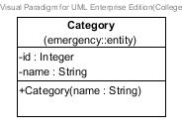

**Figure 11** Category **class**

**Entities**

|  |  |  |  |
| --- | --- | --- | --- |
| **ID** | **Name** | **Description** | **Type** |
| 1 | id | stored id of the category | Integer |
| 2 | name | stored name of the category | string |

**Method details**

1. Category

public Category(String name)

**Description:** A constructor method is used to set name of the category.

1. CategoryDAO

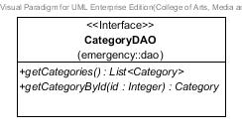

**Figure 12** CategoryDAO **class**

**Method details**

1. getCategories

public List<Category> getCategories()

**Description:** Get all categories from the database.

**Return:** List of all categories in the database.

1. getCategoryById

public Category getCategoryById(Integer id)

**Description:** Get the category, which category’s id equal to id-Integer, from the database.

**Parameter:** id-Integer uses for getting the category from the database.

**Return:** The category in the database.

1. CategoryDAOImpl

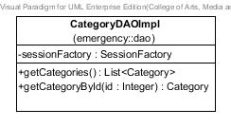

**Figure 13** CategoryDAOImpl **class**

**Entities**

|  |  |  |  |
| --- | --- | --- | --- |
| **ID** | **Name** | **Description** | **Type** |
| 1 | sessionFactory | A thread-safe, immutable cache of compiled mappings for a single database | SessionFactory |

**Method details**

1. getCategories

public List<Category> getCategories()

**Description:** Get all categories from the database by using session to query data.

**Flow:**

1. Create query to get all categories in the database.
2. Return the queried data

**Return:** List of categories in the database.

1. getCategoryById

public Category getCategoryById(Integer id)

**Description:** Get the category from the database by using session to query data.

**Parameter:** id-Integer uses for getting the category from the database.

**Flow:**

1. Create query to get the category, where category’s id equal to id-Integer.
2. Return the queried data.

**Return:** The category in the database.

1. CategoryService

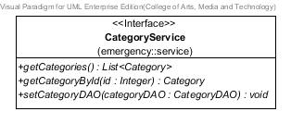

**Figure 14** CategoryService **class**

**Method details**

1. getCategories

public List<Category> getCategories()

**Description:** Get all categories from the database.

**Return:** List of all categories in the database.

1. getCategoryById

public Category getCategoryById(Integer id)

**Description:** Get the category from the database by using id-Integer.

**Parameter:** id-Integer uses for getting the category from the database.

**Return:** The category in the database.

1. setCategoryDAO

public void setCategoryDAO(CategoryDAO categoryDAO)

**Description:** Set categoryDAO value into category’s attribute.

**Parameter:** categoryDAO–CategoryDAO use for setting category DAO.

1. CategoryServiceImpl

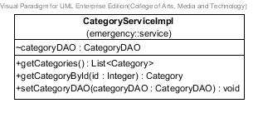

**Figure 15** CategoryServiceImpl **class**

**Method details**

1. getCategories

public List<Category> getCategories()

**Description:** Get all categories from the database through getCategories method of CategoryDAO class.

**Flow:**

1. Use method getCategories()of CategoryDAO class to get a list of all categories.
2. Return the list of all categories.

**Return:** List of all categories in the database.

1. getCategoryById

public Category getCategoryById(Integer id)

**Description:** Get the category from the database through getCategoryById method of CategoryDAO class.

**Parameter:** id-Integer uses for getting the category from the database.

**Flow:**

1. Use method getCategoryById(Integer id)of CategoryDAO class to get the category.
2. Return the category.

**Return:** The category in the database.

1. setCategoryDAO

public void setCategoryDAO(CategoryDAO categoryDAO)

**Description:** Set categoryDAO value into category’s attribute.

**Flow:**

1. Use parameter to set categoryDAO.

**Parameter:** categoryDAO–CategoryDAO use for setting category DAO.

1. Province

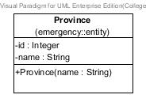

**Figure 16** Province **class**

**Entities**

|  |  |  |  |
| --- | --- | --- | --- |
| **ID** | **Name** | **Description** | **Type** |
| 1 | id | stored id of the province | Integer |
| 2 | name | stored name of the province | string |

**Method details**

1. Province

public Province(String name)

**Description:** A constructor method is used to set name of the province.

1. ProvinceDAO

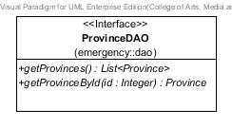

**Figure 17** ProvinceDAO **class**

**Method details**

1. getProvinces

public List<Province> getProvinces()

**Description:** Get all provinces from the database.

**Return:** List of all provinces in database.

1. getProvinceById

public Province getProvinceById(Integer id)

**Description:** Get province from the database.

**Parameter:** id-Integer uses for getting the province from database.

**Return:** The province in database.

1. ProvinceDAOImpl

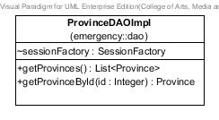

**Figure 18** ProvinceDAOImpl **class**

**Entities**

|  |  |  |  |
| --- | --- | --- | --- |
| **ID** | **Name** | **Description** | **Type** |
| 1 | sessionFactory | A thread-safe, immutable cache of compiled mappings for a single database | SessionFactory |

**Method details**

1. getProvinces

public List<Province> getProvinces();

**Description:** Get all provinces from the database by using session to query data.

**Flow:**

1. Create query to get all provinces in database.
2. Return the queried data.

**Return:** List of all provinces in database.

1. getProvinceById

public Province getProvinceById(Integer id)

**Description:** Get province from the database by using session to query data.

**Parameter:** id-Integer uses for getting the province from database.

**Flow:**

1. Create query to get the province, where province’s id equal to id-Integer.
2. Return the queried data.

**Return:** The province in database.

1. ProvinceService

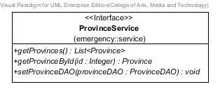

**Figure 19** ProvinceService **class**

**Method details**

1. getProvinces

public List<Province> getProvinces();

**Description:** Get all provinces from the database

**Return:** List of all provinces in database.

1. getProvinceById

public Province getProvinceById(Integer id)

**Description:** Get province from the database.

**Parameter:** id-Integer uses for getting the province from database.

**Return:** The province in database.

1. setProvinceDAO

public void setProvinceDAO(ProvinceDAO provinceDAO)

**Description:** Set provinceDAO value into province’s attribute.

**Parameter:** provinceDAO–ProvinceDAO use for setting province DAO.

1. ProvinceServiceImpl

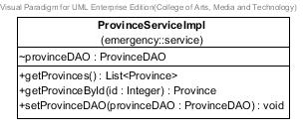

**Figure 20** ProvinceServiceImpl **class**

**Method details**

1. getProvinces

public List<Province> getProvinces()

**Description:** Get provinces from the database through getProvinces method of ProvinceDAO class.

**Flow:**

1. Use method getProvinces()of ProvinceDAO class to get a list of all provinces.
2. Return the list of all provinces.

**Return:** List of provinces in database.

1. getProvinceById

public Province getProvinceById(Integer id)

**Description:** Get province from the database through getProvinceById method of ProvinceDAO class.

**Parameter:** id-Integer uses for getting the province from database.

**Flow:**

1. Use method getProvinceById(Integer id)of ProvinceDAO class to get the province.
2. Return the province.

**Return:** The province in database.

1. setProvinceDAO

public void setProvinceDAO(ProvinceDAO provinceDAO)

**Description:** Set provinceDAO value into province’s attribute.

**Flow:**

1. Use parameter to set provinceDAO.

**Parameter:** provinceDAO–ProvinceDAO use for setting province DAO.

1. HelpPlaceController



**Figure 21** HelpPlaceController **class**

**Entities**

|  |  |  |  |
| --- | --- | --- | --- |
| **ID** | **Name** | **Description** | **Type** |
| 1 | helpPlaceService | Contained HelpPlaceService object | HelpPlaceService |
| 2 | provinceService | Contained ProvinceService object | ProvinceService |
| 3 | categoryService | Contained CategoryService object | CategoryService |

**Method details**

1. listHelpPlaces

public String listHelpPlaces(Model model)

**Description:** Show a list of help places in the home page.

**Parameter:** model-Model uses for getting the model.

**Return:** Home_page.jsp page

1. getHelpPlaceByCategoryAndProvince

public String getHelpPlaceByCategoryAndProvince

(@PathVariable("input")Integer catId,@PathVariable("input2")Integer proId, ModelMap model)

**Description:** Show a list of help places by its category, province, or category and province.

**Parameter:** model-ModelMap uses for getting the model.

proId-Integerusesfor getting help places by province’s id.

catId-Integerusesfor getting help places by category’s id.

**Return:** Home_page.jsp page

1. getHelpPlaceById

public String getHelpPlaceById

(@PathVariable("input")Integer id,ModelMap model)

**Description:** Show information of the selected help place on view information page.

**Parameter:** model-ModelMap uses for getting the model.

id-Integerusesfor getting help place by its id.

**Return:** viewInformation.jsp page

1. addHelpPlace

public String addHelpPlace(Model model)

**Description:** Show add help place page with empty boxes to input information of new help place**.**

**Parameter:** model-Model uses for getting the model.

**Return:** updateInfo.jsp page

1. updateHelpPlace

public String updateHelpPlace(@PathVariable("id") Integer id, Model model)

**Description:** Show updates information page with boxes for inputting new information.

**Parameter:** model-Model uses for getting the model.

id-Integerusesfor getting help place by its id.

**Return:** updateInfo.jsp page

1. removeHelpPlace

public String removeHelpPlace(@PathVariable("id") Integer id,RedirectAttributes redirectAttributes)

**Description:** Create command to delete the help place and create the confirmation message for removing.

**Parameter:** model-Model uses for getting the model.

id-Integerusesfor deleting help place by its id.

**Return:** Home_page.jsp page.

1. addValidHelpPlace

public String addValidHelpPlace(@Valid HelpPlace helpPlace, BindingResult bindingResult,Model model,RedirectAttributes redirectAttributes)

**Description:** Check the validation of the help place before add or update into the database.

**Parameter:** model-Model uses for getting the model.

helpPlace-HelpPlaceuses for updating the help place.

bindingResult-BindingResultuses for keeping the invalid data.

redirectAttributes-RedirectAttributesuses for store the error message.

**Return:** If there are invalid information, go to updateInfo.jsp page, otherwise go to Home_page.jsp page.

**MDs-71:** getNearestHelpPlaceJson

public @ResponseBody String getNearestHelpPlaceJson(@PathVariable("userLa") double userLa,@PathVariable("userLong") double userLong,@PathVariable("catId") Integer catId)

**Description:** Get the nearest help place in JSON form.

**Parameter:** userLa-double use for get user latitude.

userLong-double use for get user longitude.

catId -Integer use for get help places by the selected category.

**Return:** Information of the nearest help place in form of Json.

**MDs-72:** listHelpPlacesJson

public @ResponseBody String listHelpPlacesJson()

**Description:** Get list of all help places in JSON form.

**Parameter:** -

**Return:** Information of all help places in form of Json.

**MDs-73:** listHelpPlacesInScopeJson

public @ResponseBody String listHelpPlacesInScopeJson(@PathVariable("userLa") double userLa,@PathVariable("userLong") double userLong,@PathVariable("scope") double scope)

**Description:** Get list of all help places, where locate in the setting scope, in JSON form.

**Parameter:** userLa-double use for get user latitude.

userLong-double use for get user longitude.

scope -double use for define area to get help places.

**Return:** Information of help places, where locate in the setting scope, in form of Json.

3.2.2 Mobile Part

1. HelpPlace

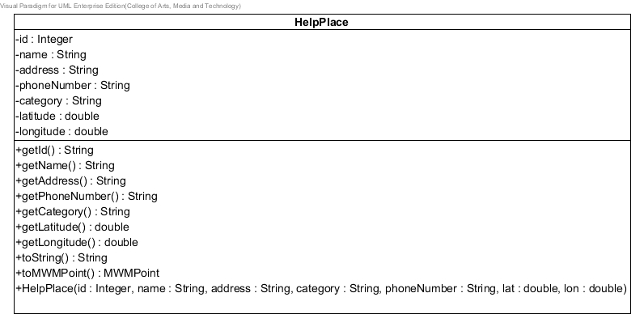

**Figure 22 HelpPlace class**

**Entities**

|  |  |  |  |
| --- | --- | --- | --- |
| **ID** | **Name** | **Description** | **Type** |
| 1 | id | Store id of help place | Integer |
| 2 | name | Store name of help place | String |
| 3 | address | Store address of help place | String |
| 4 | telephone | Store telephone of help place | String |
| 5 | category | Store category of help place | String |
| 6 | latitude | Store latitude of help place | double |
| 7 | longitude | Store longitude of help place | double |

1. HelpPlaceService

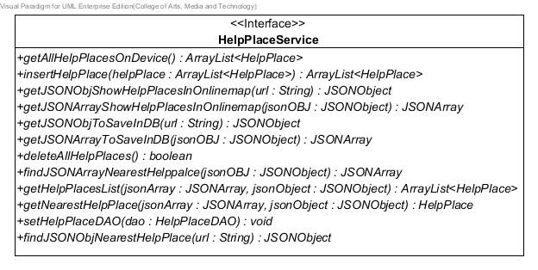

**Figure 23 HelpPlaceService class**

**Method details**

1. getJSONObjShowHelpPlacesInOnlineMap

public JSONObject getJSONObjShowHelpPlacesInOnlineMap (String url)

**Description:** Get Json object by use url of server.

**Parameters:** url-string uses to get Json object file from server.

**Return:** Json object, if invalid input returns null

1. getJSONArrayShowHelpPlacesInOnlineMap

public JSONArray getJSONArrayShowHelpPlacesInOnlineMap (JSONObject jsonOBJ)

**Description:** Get Json array by use Json object that receive from getJsonObjShowHelpPlacesInOnlineMap method.

**Parameters:** jsonOBJ-JSONObject uses to get Json array from getJsonObjShowHelpPlacesInOnlineMap method.

**Return:** Json array, if invalid input returns null

1. getJSONObjToSaveInDB

public JSONObject getJSONObjToSaveInDB (String url)

**Description:** Get Json object by use url of server.

**Parameters:** url-string uses to get Json object file from server.

**Return:** Json object, if invalid input returns null

1. getJSONArrayToSaveInDB

public JSONArray getJSONArrayToSaveInDB (JSONObject jsonOBJ)

**Description:** Get Json array by use Json object that receive from getJSONObjToSaveInDB method.

**Parameters:** jsonOBJ-JSONObject uses to get Json array from getJSONObjToSaveInDB method.  **Return:** Json array, if invalid input returns null

1. findJSONObjNearestHelpPlace

public JSONObject findJSONObjNearestHelpPlace(String url)

**Description:** Get Json object by use url of server.

**Parameters:** url-string uses to get Json object file from server.

**Return:** Json object, if invalid input returns null

1. findJSONArrayNearestHelpPlace

public JSONArray findJSONArrayNearestHelpPlace(JSONObject jsonOBJ)

**Description:** Get Json array by use Json object that receive from findJSONArrayNearestHelpPlace method.

**Parameters:** jsonOBJ-JSONObject uses to get Json array from findJSONArrayNearestHelpPlace method.

**Return:** Json array, if invalid input returns null

1. getHelpPlacesList

public ArrayList<HelpPlace> getHelpPlacesList(JSONArray jsonArray,JSONObject jsonObject)

**Description:** Get Array list of help place object by inputting JSONArray and JSONObj

**Parameters:** jsonArray - JSONArray, JSONObject - jsonObject

**Return:** Array List of help place object, if invalid input returns null

1. getNearestHelpPlace

public HelpPlace getNearestHelpPlace(JSONArray jsonArray,JSONObject jsonObject)

**Description:** Get help place object by inputting JSONArray and JSONObj.

**Parameters:** jsonArray - JSONArray, JSONObject - jsonObject.

**Return:** Help place object, if invalid input returns null

1. setHelpPlaceDAO

public void setHelpPlaceDAO(HelpPlaceDAO dao)

**Description:** Set HelpPlaceDAO value into dao attribute.

**Parameters:** HelpPlaceDAO dao.

1. deleteAllHelpPlaces

public boolean deleteAllHelpPlaces ()

**Description:** Delete all help places in database.

**Return:** Boolean, if all help places in database that deleted, will return true.

1. getAllHelpPlacesOnDevice

public ArrayList<HelpPlace> getAllHelpPlacesOnDevice()

**Description:** Get all help places from database on the mobile device.

**Return:** Array List of help place object, if invalid input returns null

1. insertHelpPlace

public ArrayList<HelpPlace> insertHelpPlace(ArrayList<HelpPlace> helpPlace)

**Description:** Insert help place into database by inputting array list of help place.

**Parameters:** helpPlace - ArrayList<HelpPlace>

**Return:** Array List of help place object, if invalid input returns null

1. HelpPlaceServiceImpl

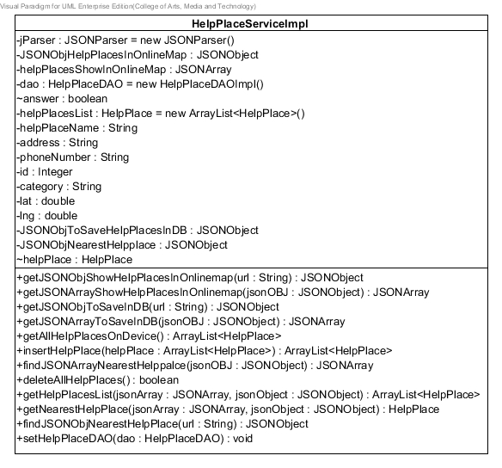

**Figure 24 HelpPlaceServiceImpl class**

**Entities**

|  |  |  |  |
| --- | --- | --- | --- |
| **ID** | **Name** | **Description** | **Type** |
| 1 | jParser | Store JSON parser | JSONParser |
| 2 | JSONObjectHelpPlacesInOnlineMap | Store JSON Object | JSONObject |
| 3 | helpPlacesShowInOnlineMap | Store help places as JSON array | JSONArray |
| 4 | dao | Store HelpPlaceDAO object | HelpPlaceDAO |
| 5 | answer | Store value of Boolean (true or false) | boolean |
| 6 | helpplaceList | Store HelpPlace object in array list | ArrayList<HelpPlace> |
| 7 | helpPlaceName | Store help place name | String |
| 8 | address | Store help place address | String |
| 9 | phoneNumber | Store help place phone number | String |
| 10 | id | Store help place ID | Integer |
| 11 | category | Store help place category | String |
| 12 | lat | Store help place latitude | Double |
| 13 | lng | Store help place longitude | Double |
| 14 | JSONObjToSaveHelpPlacesInDB | Store JSONObject | JSONObject |
| 15 | JSONObjNearestHelpplace | Store JSONObject | JSONObject |
| 16 | helpPlace | Store help place object | HelpPlace |

**Method details**

1. getJSONObjShowHelpPlacesInOnlineMap

public JSONObject getJSONObjShowHelpPlacesInOnlineMap (String url)

**Description:** Get Json object by use url of server.

**Parameters:** url-string uses to get Json object file from server.

**Flow:**

1. Set JSONObject equal to jParser to call getJSONObjShowHelpPlacesInOnlineMap method and use url parameter.
2. Return JSONObject

**Return:** Json object, if invalid input returns null

1. getJSONArrayShowHelpPlacesInOnlineMap

public JSONArray getJSONArrayShowHelpPlacesInOnlineMap (JSONObject jsonOBJ)

**Description:** Get Json array by use Json object that receive from getJsonObjShowHelpPlacesInOnlineMap method.

**Parameters:** jsonOBJ-JSONObject uses to get Json array from getJsonObjShowHelpPlacesInOnlineMap method.

**Flow:**

1. Set JSONArray variable equal to JSONObject to call getJSONArray method.
2. Return helpPlaceArray.

**Return:** Json array, if invalid input returns null

1. getJSONObjToSaveInDB

public JSONObject getJSONObjToSaveInDB (String url)

**Description:** Get Json object by use url of server.

**Parameters:** url-string uses to get Json object file from server.

**Flow:**

1. Set JSONObject equal to jParser to call getJSONObjToSaveInDB method and use url parameter.
2. Return JSONObject.

**Return:** Json object, if invalid input returns null

1. getJSONArrayToSaveInDB

public JSONArray getJSONArrayToSaveInDB (JSONObject jsonOBJ)

**Description:** Get Json array by use Json object that receive from getJSONObjToSaveInDB method.

**Parameters:** jsonOBJ-JSONObject uses to get Json array from getJSONObjToSaveInDB method.

**Flow:**

1. Set JSONArray variable equal to JSONObject to call getJSONArray method.
2. Return helpPlaceArray.

**Return:** Json array, if invalid input returns null

1. findJSONObjNearestHelpPlace

public JSONObject findJSONObjNearestHelpPlace(String url)

**Description:** Get Json object by use url of server.

**Parameters:** url-string uses to get Json object file from server..

**Flow:**

1. Set JSONObject equal to jParser to call getJSONObjToSaveInDB method and use url parameter.
2. Return JSONObject.

**Return:** Json object, if invalid input returns null

1. findJSONArrayNearestHelpPlace

public JSONArray findJSONArrayNearestHelpPlace(JSONObject jsonOBJ)

**Description:** Get Json array by use Json object that receive from findJSONArrayNearestHelpPlace method.

**Parameters:** jsonOBJ-JSONObject uses to get Json array from findJSONArrayNearestHelpPlace method.

**Flow:**

1. Set JSONArray variable equal to JSONObject to call getJSONArray method.
2. Return helpPlaceArray.

**Return:** Json array, if invalid input returns null

1. getHelpPlacesList

public ArrayList<HelpPlace> getHelpPlacesList(JSONArray jsonArray,JSONObject jsonObject)

**Description:** Get Array list of help place object by inputting JSONArray and JSONObj

**Parameters:** jsonArray - JSONArray, JSONObject - jsonObject

**Flow:**

1. Set JSONArray and JSONObject variable to add value as HelpPlace in array list.
2. Return Array list of HelpPlace.

**Return:** Array List of help place object, if invalid input returns null

1. getNearestHelpPlace

public HelpPlace getNearestHelpPlace(JSONArray jsonArray,JSONObject jsonObject)

**Description:** Get help place object by inputting JSONArray and JSONObj.

**Parameters:** jsonArray - JSONArray, JSONObject - jsonObject

**Flow:**

1. Set JSONArray and JSONObject variable to add value as HelpPlace in array list.
2. Return HelpPlace.

**Return:** Help place object, if invalid input returns null

1. setHelpPlaceDAO

public void setHelpPlaceDAO(HelpPlaceDAO dao)

**Description:** Set HelpPlaceDAO values into dao attribute.

**Parameters:** HelpPlaceDAO dao

**Flow:**

1. Get parameter to set value of helpPlaceDAO attribute.
2. deleteAllHelpPlaces

public boolean deleteAllHelpPlaces ()

**Description:** Delete all help places in database.

**Flow:**

1. Use method deleteAllHelpPlaces( ) of HelpPlaceDAO class to delete help place.
2. Return Boolean true.

**Return:** Boolean, if all help places in database that deleted, will return true.

1. getAllHelpPlacesOnDevice

public ArrayList<HelpPlace> getAllHelpPlacesOnDevice()

**Description:** Get all help places from database on the mobile device.

**Flow:**

1. Use method getAllHelpPlaces ( ) of HelpPlaceDAO class to get all help places.
2. Return array list of help place.

**Return:** Array List of help place object, if invalid input returns null

1. insertHelpPlace

public ArrayList<HelpPlace> insertHelpPlace(ArrayList<HelpPlace> helpPlace)

**Description:** Insert help place into database by inputting array list of help place.

**Parameters:** helpPlace - ArrayList<HelpPlace>

**Flow:**

1. Use method insertHelpPlace (helpPlace) of HelpPlaceDAO class to insert array list of help places.
2. Return help place object.

**Return:** Array List of help place object that contained, if invalid input returns null

1. HelpPlaceSingleton

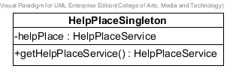

**Figure 25 HelpPlaceSingleton class**

**Entities**

|  |  |  |  |
| --- | --- | --- | --- |
| **ID** | **Name** | **Description** | **Type** |
| 1 | helpPlace | Store HelpPlaceService object | HelpPlaceService |

**Method details**

1. getHelpPlaceService

public HelpPlaceService getHelpPlaceService ()

**Description:** Get HelpPlaceService with static value.

**Flow:**

1. Set helpPlace attribute to equal new HelpPlaceServiceImpl ( )
2. Return helpPlace.

**Return:** Help place object, if invalid input returns null.

1. OnlineMapController

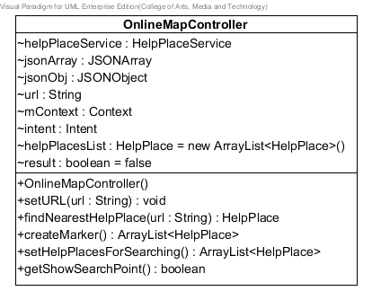

**Figure 26 OnlineMapController class**

**Entities**

|  |  |  |  |
| --- | --- | --- | --- |
| **ID** | **Name** | **Description** | **Type** |
| 1 | helpPlaceService | Create help place service object | HelpPlaceService |
| 2 | mContext | Store context object | Context |
| 3 | intent | Store intent | Intent |
| 4 | jsonArray | Store help place in Json array | JSONArray |
| 5 | result | Store Boolean (true or false) | boolean |
| 6 | url | Store url of server | String |
| 7 | helpPlaceList | Store HelpPlace in array list | ArrayList<HelpPlace> |
| 8 | jsonObj | Store Json object | JSONObject |

**Method details**

1. OnlineMapController

public OnlineMapController(String url)

**Description:** a constructor method uses to set url attribute.

**Parameters:** url-String uses for getting the url for setting into service.

**Flow:**

1. A constructor method gets url from parameter.
2. Create object helpPlaceService.
3. Define value to json attribute equal to helpPlaceService.getJsonObjByURL(url)
4. createMarker

public ArrayList<HelpPlace> createMarker ()

**Description:** Create marker with information of help place.

**Parameters:** None

**Flow:**

1. Input url to get JSONObject by using method findJSONObjShowHelpPlacesInOnlineMap of HelpPlaceService class.
2. Input JSONObject to get JSONArray in method findJSONArrayShowHelpPlacesInOnlineMap of HelpPlaceService class.
3. Input JSONObject and JSONArray as parameter in method getHelpPlacesList of HelpPlaceService class
4. Return Array list of Help place object.

**Return:** Array list of Help place object , if invalid input returns null.

1. setURL

public void setURL(String url)

**Description:** Set url to connect with the server

**Parameters:** url-String uses for setting url of server

**Flow:**

1. Set valiable url with the parameter that received.
2. Input url in to method getJSONObjShowHelpPlacesInOnlinemap of HelpPlaceService class.
3. findNearestHelpPlace

public HelpPlace findNearestHelpPlace(String url)

**Description:** Set url to connect with the server to find the nearest help place

**Parameters:** url-String uses for setting url of server

**Flow:**

1. Set valiable url with the parameter that received.
2. Input url to get JSONObject by using method findJSONObjNearestHelpPlace of HelpPlaceService class.
3. Input JSONObject to get JSONArray in method findJSONArrayNearestHelppalce of HelpPlaceService class.
4. Input JSONObject and JSONArray as parameter in method getNearestHelpPlace of HelpPlaceService class
5. Return Help place object.

**Return:** Help place object, if invalid input returns null.

1. setHelpPlacesForSearching

public ArrayList<HelpPlace> setHelpPlacesForSearching ()

**Description:** Set help places into array list.

**Flow:**

1. Input url to get JSONObject by using method findJSONObjShowHelpPlacesInOnlineMap of HelpPlaceService class.
2. Input JSONObject to get JSONArray in method findJSONArrayShowHelpPlacesInOnlineMap of HelpPlaceService class.
3. Input JSONObject and JSONArray as parameter in method getHelpPlacesList of HelpPlaceService class
4. Return Array list of Help place object.

**Return:** Array list of Help place object, if invalid input returns null

1. getShowSearchPoint

public boolean getShowSearchPoint()

**Description:** Get result of searching point.

**Flow:**

1. Set condition if result : Boolean equal true.
2. mContext variable call method startActivity by inputting intent
3. return result as Boolean value.

**Return:** Boolean, if all help places in database that deleted, will return true.

1. OffllineMapController

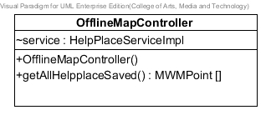

**Figure 27 OfflineMapController class**

**Entities**

|  |  |  |  |
| --- | --- | --- | --- |
| **ID** | **Name** | **Description** | **Type** |
| 1 | service | Create help place service ohject | HelpPlaceServiceImpl |

**Method details**

1. OfflineMapController

public OfflineMapController()

**Description:** a constructor method uses to set helpPlaceService attribute.

**Parameters:** hPlaces-HelpPlaces use to set value to an array.

**Flow:**

1. Use this.helpPlaceService attribute equal to helpPlaceService parameter.
2. getAllHelpplaceSaved

public HelpPlaces[] getAllHelpplaceSaved ()

**Description:** Get help places from database of user’s device.

**Parameters:** None

**Flow:**

1. Initial value of helpPlacesOnDevice variable by use method getHelpplaceFromDevice of HelpPlaceServiceImpl.
2. Return help place array.

**Return:** HelpPlaces array, if invalid value returns null.

1. InformationView

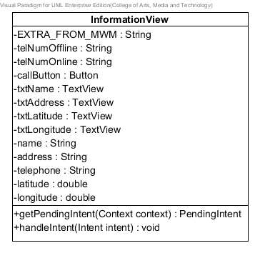

**Figure 28 InformationView class**

**Entities**

|  |  |  |  |
| --- | --- | --- | --- |
| **ID** | **Name** | **Description** | **Type** |
| 1 | EXTRA_FROM_MWM | Store string “from-maps-with-me” | String |
| 2 | telNumOffline | Store telephone number of offline map | String |
| 3 | telNumOnline | Store telephone number of online map | String |
| 4 | callButton | Store value from telephone number to phone call button | Button |
| 5 | txtName | Store name of help place | TextView |
| 6 | txtAddress | Store address of help place | TextView |
| 7 | txtLatitude | Store latitude of help place | TextView |
| 8 | txtLongitude | Store longitude of help place | TextView |
| 9 | name | Store name of help place | String |
| 10 | address | Store address of help place | String |
| 11 | telephone | Store telephone of help place | String |
| 12 | latitude | Store latitude of help place | double |
| 13 | longitude | Store longitude of help place | double |

**Method details**

1. getPendingIntent

public PendingIntent getPendingIntent (Context context)

**Description:** Set pending intent value.

**Parameters:** Context-Context uses for input as a parameter to create Intent object.

**Flow:**

1. Create Intent object to use InforamtionController.class as parameter.
2. Set intent to use putExtra method and input *EXTRA_FROM_MWM* as parameter.
3. Return PendingIntent to use getActivity method.

**Return:** PendingIntent, if invalid input returns null.

1. handleIntent

public void handleIntent(Intent intent)

**Description:** Set information of help place that selected by handle.

**Parameters:** intent-Intent use to get and set value.

**Flow:**

1. Use intent to getBooleanExtra method in if condition
2. Create MWMResponse object for using extractFromIntent method.
3. Set helpPlace variable to equal HelpPlaceServiceImpl.*fromMWMPoint*(response.getPoint());
4. Check helpPlace not null to set text into Text View.

1. JSONParser

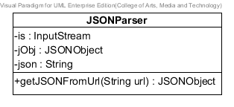

**Figure 29 JSONParser class**

**Entities**

|  |  |  |  |
| --- | --- | --- | --- |
| **ID** | **Name** | **Description** | **Type** |
| 1 | is | Store value form data source | InputStream |
| 2 | jObj | Store Json object | JSONObject |
| 3 | json | Use for creating new object of JSONObject | String |

**Method details**

1. getJSONFromUrl

public JSONObject getJSONFromUrl (String url)

**Description:** Get Json object by receive url of server.

**Parameters:** url-string uses to get url of server.

**Flow:**

1. Create object of DefaultHttpClient, HttpPost, HttpResponse, HttpEntity and set value to attribute “is” to use HttpEntity to get Content.
2. Use BufferReader to read InputStreamReader.
3. Keep value from readLine into StringBuilder append.

**Return:** Json object, if invalid input returns null.

1. PhoneCallListener

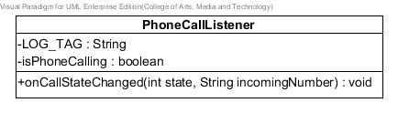

**Figure 30 PhoneCallListener class**

**Entities**

|  |  |  |  |
| --- | --- | --- | --- |
| **ID** | **Name** | **Description** | **Type** |
| 1 | LOG_TAG | Use for test Log status | String |
| 2 | isPhoneCalling | Use to check state of TelephonyManager | boolean |

**Method details**

1. onCallStateChanged

public void onCallStateChanged (int state,String incomingNumber)

**Description:** Set state of the phone call.

**Parameters:** state-integer uses check compare with TelephonyManager state.

incomingNumber-String uses to set telephone number.

**Flow:**

1. Defind condition to check TelephonyManager state (CALL_STATE_RINGING, CALL_STATE_OFFHOOK, CALL_STATE_IDLE)

1. DatabaseConnection

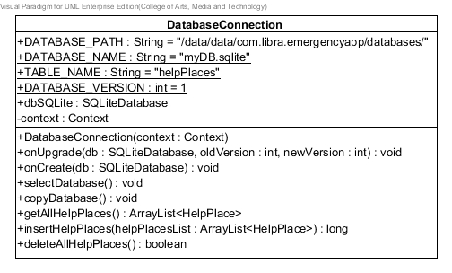

**Figure 31 DatabaseConnection class**

**Entities**

|  |  |  |  |
| --- | --- | --- | --- |
| **ID** | **Name** | **Description** | **Type** |
| 1 | DATABASE_PATH | Store path of file SQLite | String |
| 2 | DATABASE_NAME | Store name of file SQLite | String |
| 3 | TABLE_NAME | Store name of table in database | String |
| 4 | DATABASE_VERSION | Store number version of database | Integer |
| 5 | dbSQLite | Store command to use database | SQLiteDatabase |
| 6 | context | Store context to call getAssets() | Context |

**Method details**

1. selectDatabase

public void selectDatabase ()

**Description:** Select database to use getWritableDatabase method to set dbSQLite.

**Parameters:** None

**Flow:**

1. Set value into dbSQLite variable equal to this.getWritableDatabase method.
2. copyDatabase

public void copyDatabase ()

**Description:** Copying database from resource SQLite.

**Parameters:** None

**Flow:**

1. Create variable InptStream and OutputStream are null.
2. Use context to call getAsset method to open database.
3. Use while condition for InputStream reading buffer
4. geAllHelpPlaces

public ArrayList <HelpPlace> getAllHelpPlaces ()

**Description:** Copying database from resource SQLite.

**Parameters:** None

**Flow:**

1. Write command to get information from database “Select * from (name of database)”
2. Set value to some variable by use cursor , getInteger, getString and getDouble method for putting value into HelpPlace.
3. Put HelpPlace object into an array list.
4. Return an array list.

**Return:** Array list, if invalid value returns null.

1. DatabaseConnection

public DatabaseConnection(Context context)

**Description:** Set context, database name and database version

**Parameters:** Context context

**Flow:**

1. Set context, database name and database as parameter of super class.
2. insertHelpPlaces

public long insertHelpPlaces(ArrayList<HelpPlace> helpPlacesList)

**Description:** Insert array list of HelpPlace into database

**Parameters:** ArrayList<HelpPlace> helpPlaceList

**Flow:**

1. Use for each to set value of HelpPlace object into database.
2. Insert command by using method insert of SQLiteDatabase.
3. Return rows of help place.

**Return:** rows of help places in database, if invalid value returns null.

1. deleteAllHelpPlaces

public boolean deleteAllHelpPlaces()

**Description:** delete all help places from database

**Flow:**

1. Use for each to set value of HelpPlace object into database.
2. Insert command by using method insert of SQLiteDatabase.
3. Return rows of help place.

**Return:** Boolean, if all help places in database that deleted, will return true.

1. CheckingDistance

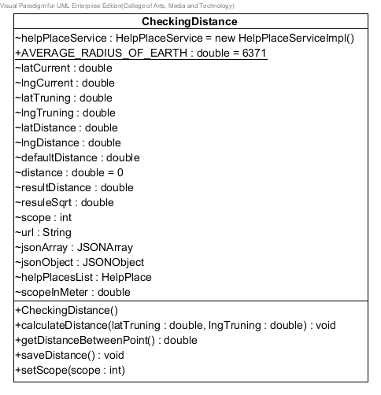

**Figure 32 CheckingDistance class**

**Entities**

|  |  |  |  |
| --- | --- | --- | --- |
| **ID** | **Name** | **Description** | **Type** |
| 1 | helpPlaceService | Store HelpPlaceService object | HelpPlaceService |
| 2 | *AVERAGE_RADIUS_OF_EARTH* | Store final value of average radius of earth | Double |
| 3 | latCurrent | Store latitude in last position | Double |
| 4 | lngCurrent | Store longitude in last position | Double |
| 5 | latTruning | Store latitude in new position | Double |
| 6 | lngTruning | Store longitude in new position | Double |
| 7 | latDistance | Store latitude different distance | Double |
| 8 | lngDistance | Store longitude different distance | Double |
| 9 | defaultDistance | Store default distance | Double |
| 10 | distance | Store distance | Double |
| 11 | resultDistance | Store value calculating in sin, cos, tan | Double |
| 12 | resultSqrt | Store value calculating in sqrt | Double |
| 13 | scope | Store scope of saving HelpPlace | int |
| 14 | url | Store URL of server | String |
| 15 | helpPlacesList | Store array list of HelpPlace | ArrayList<HelpPlace> |
| 16 | jsonArray | Store JSON Array | JSONArray |
| 17 | jsonObject | Store JSON Object | JSONObject |
| 18 | scopeInMeter | Store number of scope in meter | Double |

1. setScope

public void setScope (int scope)

**Description:** Setting scope by inputting scope as parameter

**Parameters:** scope – int

**Flow:**

1. Set number of scope that receive in parameter
2. calculateDistance

public void calculateDistance(double latTruning, double lngTruning)

**Description:** Calculate distance by receiving new position as latTruning and lngTruning in parameter

**Parameters:** latTruning – double, lngTruning - double

**Flow:**

1. Set variable equal with parameter
2. Set value to calculate with class math toRadians
3. Calculate in math class with sin, cos and tan.
4. Average distance
5. Check condition to save new information into database.
6. getDistanceBetweenPoint

public double getDistanceBetweenPoint()

**Description:** Get distance from calculateDistance method

**Flow:**

1. Return distance of method calculateDistance

**Return:** distance, if all help places in database that deleted, will return 0.

1. saveDistance

public void saveDistance()

**Description:** Get distance from calculateDistance method

**Flow:**

1. Use deleteAllHelpPlaces method of helpPlaceService class.
2. input URL to get JSONObject and JSONArray
3. Use getHelpPlacesList method of HelpPlaceService class by inputting JSONObject and JSONArray as parameter
4. Get help place list
5. Insert list of help place by use insertHelpPlace method of HelpPlaceService class.
6. SearchingHelpPlaces

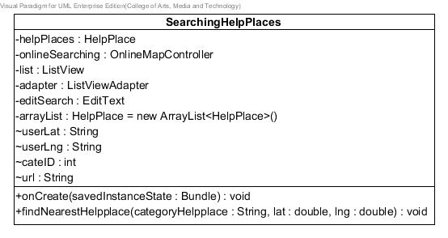

**Figure 33 SearchingHelpPlace class**

**Entities**

|  |  |  |  |
| --- | --- | --- | --- |
| **ID** | **Name** | **Description** | **Type** |
| 1 | helpPlace | Store HelpPlace object | HelpPlace |
| 2 | onlineSearching | Store OnlineMapController object | OnlineMapController |
| 3 | list | Store ListView | ListView |
| 4 | adapter | Store ListViewAdapter | ListViewAdapter |
| 5 | editSearch | Store EditText | EditText |
| 6 | arrayList | Store array list of HelpPlace | ArrayList <HelpPlace> |
| 7 | userLat | Store latitude of user | Double |
| 8 | userLng | Store longitude of user | Double |
| 8 | cateID | Store category’s ID | int |
| 9 | url | Store URL of server | String |

1. findNearestHelpplace

public void findNearestHelpplace(String categoryHelpplace, double lat, double lng)

**Description:** Find nearest help place by inputting name of category, latitude and longitude.

**Parameters:** categoryHelpplace – String, lat – double, lng – double

**Flow:**

1. Generate URL by inputting latitude and longitude
2. Check condition and set category id to input as URL
3. Use findNearestHelpPlace method of OnlineMapController class.
4. DatabaseConnectionSingleton

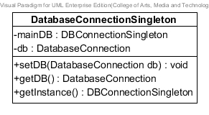

**Figure 34 DatabaseConnectionSingleton class**

**Entities**

|  |  |  |  |
| --- | --- | --- | --- |
| **ID** | **Name** | **Description** | **Type** |
| 1 | mainDB | Store static DBConnectionSingleton | DBConnectionSingleton |
| 2 | db | Store static DatabaseConnection | DatabaseConnection |

1. setDB

public void setDB(DatabaseConnection db)

**Description:** Set database connection.

**Parameters:** db – DatabaseConnection

**Flow:**

1. Set db variable is equal receiving parameter
2. getDB

public DatabaseConnection getDB()

**Description:** Get database connection.

**Flow:**

1. Set db variable is equal receiving parameter

**Return:** database Connection, if all help places in database that deleted, will return null.

1. getInstance

public DBConnectionSingleton getInstance()

**Description:** Get instance from DBconnectionSingleton.

**Flow:**

1. Get instance of DBconnectionSingleton

**Return:** database Connection Singleton, if all help places in database that deleted, will return null.

## 3.3 Sequence Diagram

3.3.1 Server Part

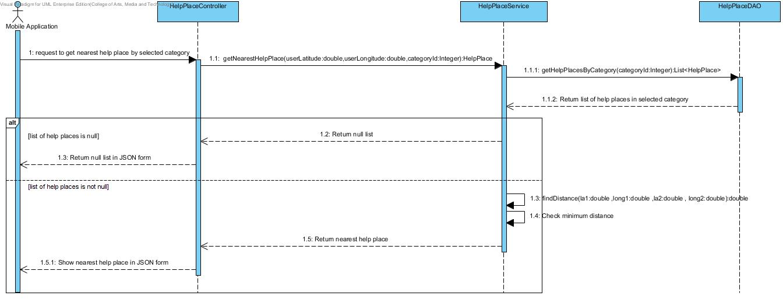

**Figure 35 Get nearest help place diagram (SD-16)**

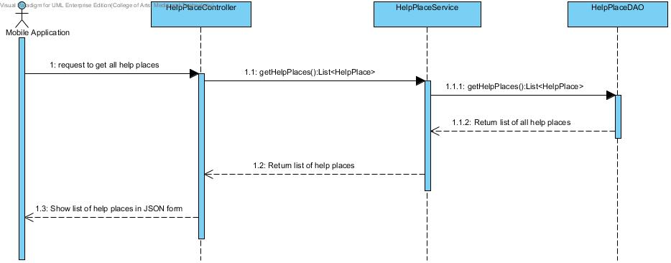

**Figure 36 Get all help places diagram (SD-17)**

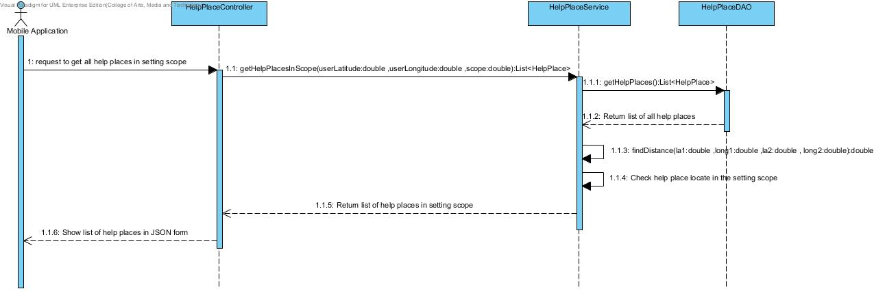

**Figure 37 Get all help places in setting scope diagram (SD-18)**

* + 1. **Mobile** **Part**

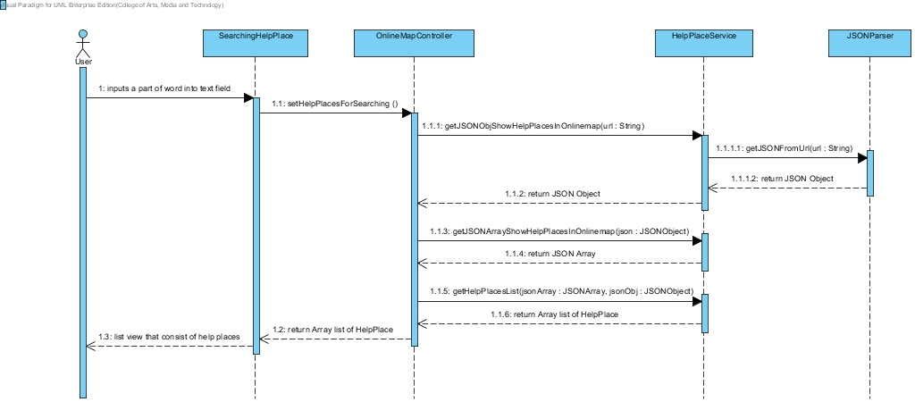

**Figure 38 Search help place’s name by keyword in online map diagram (SD-19)**

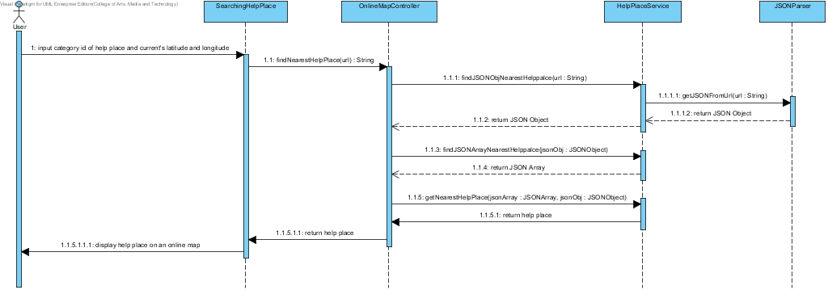

**Figure 39 Find the nearest help place diagram (SD-20)**

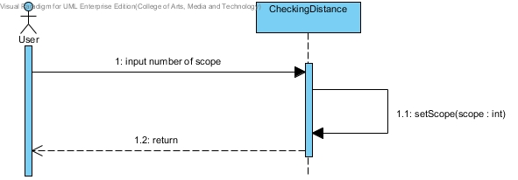

**Figure 40 Set the scope for downloading data diagram (SD-21)**

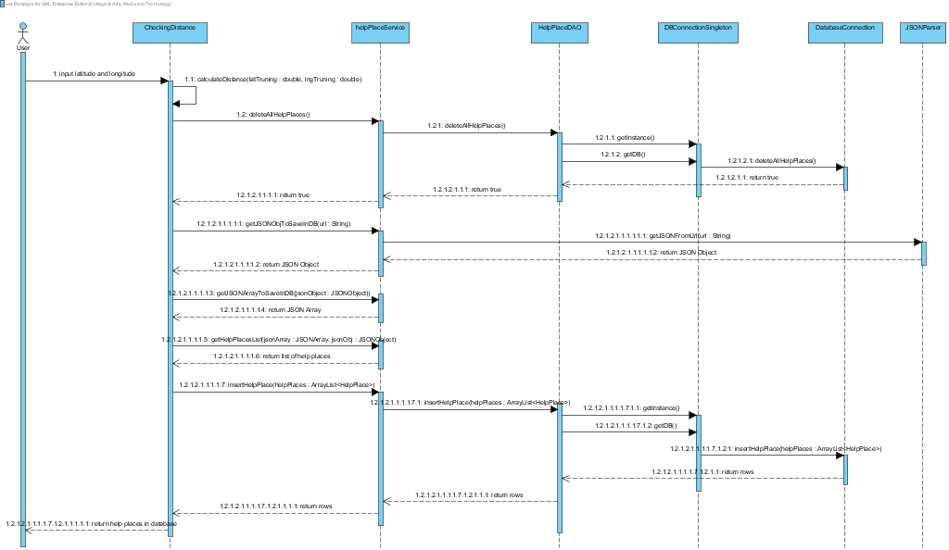

**Figure 41 Collect help place information automatically diagram (SD-22)**

# Chapter Four | User Interface Design

**UI name:** Start Page (UI-07)

Include Requirement: UC-08, UC-09, UC-10, UC-19, UC-20

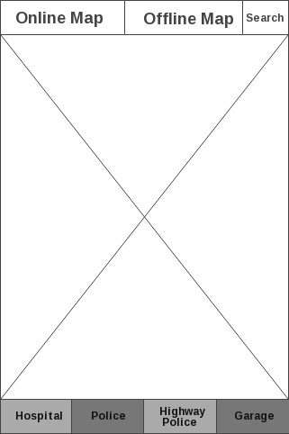

**Figure 42 Start Page (UI-07)**

The start page shows the online map automatic and buttons for user to switching map.

• Online map

• Offline map

• Search

Buttons are used to find nearest help place by category hospital, police station, highway police and garage.

**UI name:** Show Online map (UI-08)

Include Requirement: UC-08, UC-10, UC-19, UC-20, UC-22

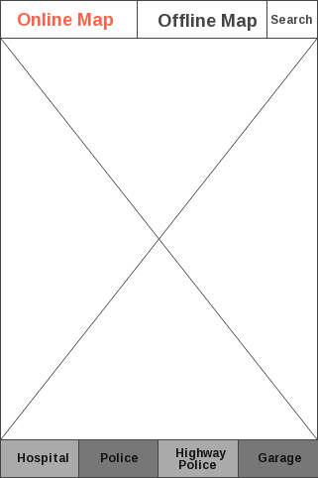

**Figure 43 Show Online map (UI-08)**

The switcher tab online button shows the online map for automatic on Start page. The online map will provide search bar to user search help place on the online map. The button allows users to access the online map.

**UI name:** Connect Offline map (UI-09)

Include Requirement: UC-09

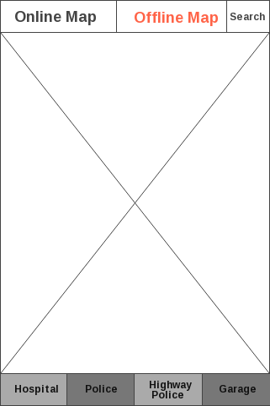

**Figure 44 Connect Offline map (UI-09)**

The switcher tab offline button shows the offline map for Start page. The button allows users to access the offline map.

**UI name:** Show Offline map (UI-10)

Include Requirement: UC-09, UC-11, UC-22



**Figure 45 Show Offline map (UI-10)**

MapsWithMe application will show Thailand offline map. The offline map will show automatic when the application lost internet connection.

**UI name:** MapsWithMe application installed (UI-11)

Include Requirement: UC-09, UC-11

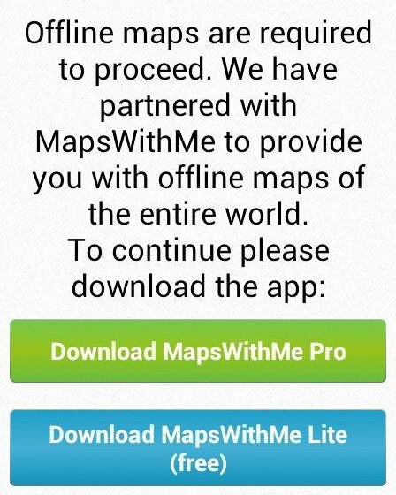

**Figure 46 MapsWithMe application installed (UI-11)**

What will happen if the user call for offline map but MapsWithMe application is not installed? The API library will show a simple dialog with a gentle offer to download MapsWithMe.

**UI name:** MapsWithMe application (UI-12)

Include Requirement: UC-11, UC-13

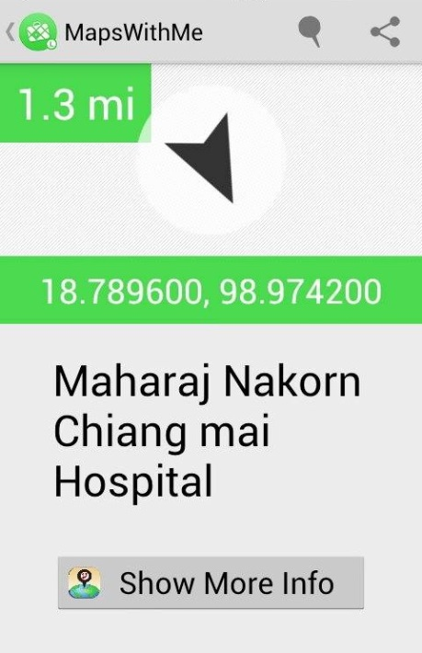

**Figure 47 MapsWithMe application (UI-12)**

MapsWithMe application will start with show offline map. The user selects the help place on offline map to view information. MapsWithMe provides latitude, longitude, name and show more info button.

**UI name:** Show Information Page (UI-13)

Include Requirement: UC-12,UC-13, UC-14, UC-15

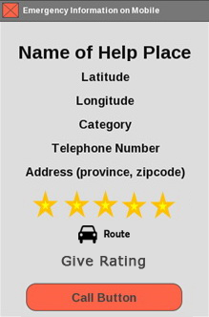

**Figure 48 Show Information Page (UI-13)**

The Show Information page will show latitude, longitude, address, category, telephone number, average rating score and call button. On show information page, the user can call to help place directly from the application.

**UI name:** Search Help place Page (UI-14)

Include Requirement: UC-19

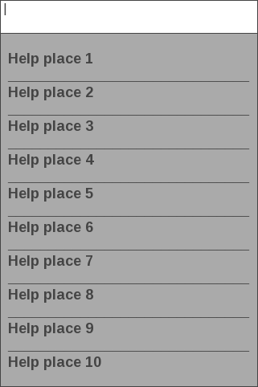

**Figure 49 Search Help place Page (UI-14)**

The Show Information page will show latitude, longitude, address, province, zip code and call button. On show information page, the user can call to help place directly from the application.

**UI name:** Setting scope (UI-15)

Include Requirement: UC-21

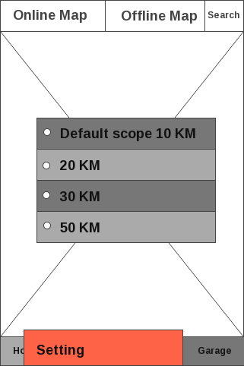

**Figure 50 Setting Scope (UI-15)**

Setting Scope that will provide menu bar for click setting menu before show the radio button with umber of scope in kilometer.